Name : Evan Diantha Fafian

Class : SIB 2G

Absent : 09

NIM : 2341760163

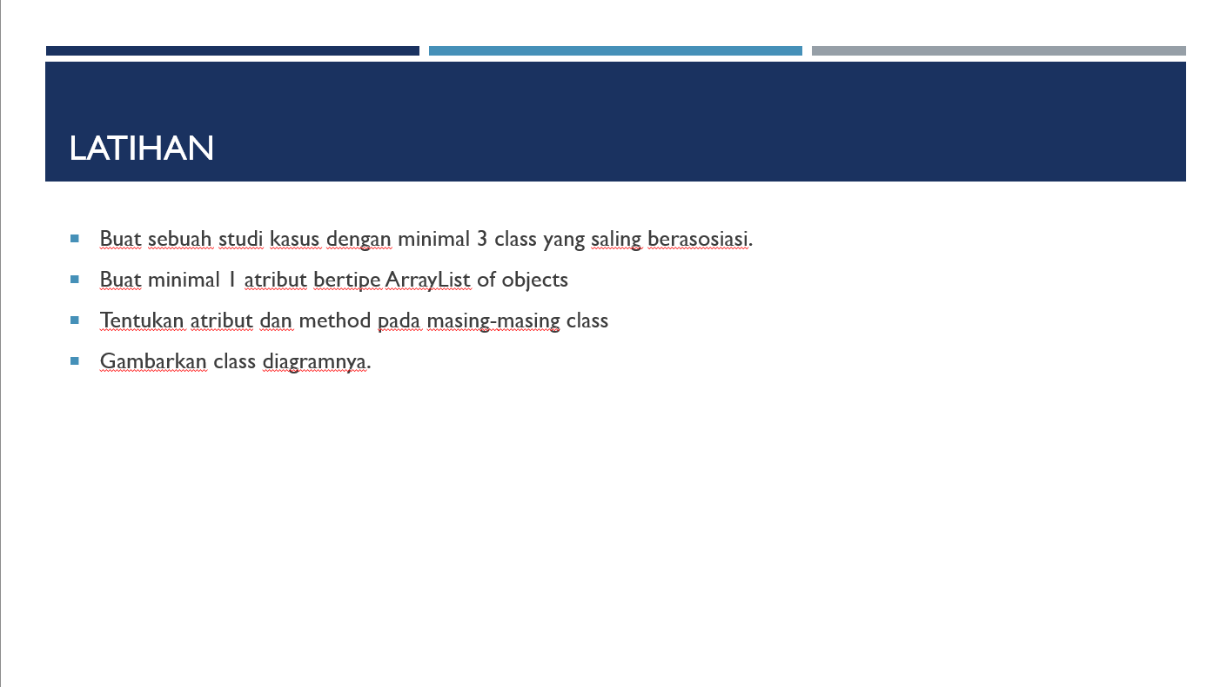

* **Study Case**

In the car service system, there are three main classes: mechanic, service, and car. Each car can have many services recorded in serviceHistory, which is a list of services that have been performed on the car. Each service contains information about the date of service, the mechanic who performed the service, and a description of the service. Mechanics have attributes like ID and name, and each service is associated with one mechanic who performed the service. When a car is serviced, the mechanic who performed the service is identified.

* **Class Descriptions**

1. Class mechanic

* Atribute :
* id (String)
* name (String)
* Method :
* getId() = Get the mechanic's ID.
* setId(String id) = Set the mechanic's ID.
* getName() = Get the mechanic's name.
* setName(String name) = Set the mechanic's name.
* getInfo() = returns a string containing the information of the mechanic.

1. Class service

* Atribute :
* date (LocalDate)
* mechanic (mechanic)
* description (String)
* Method :
* getDate() = Get the service date.
* setDate(LocalDate date) = Set the service date.
* getMechanic() = Get the mechanic.
* setMechanic(mechanic mechanic) = Set the mechanic.
* getDescription() = Get the service description.
* setDescription(String description) = Set the service description.
* getInfo() = returns a string with the details of the service, including the information of the mechanic.

1. Class car

* Atribute :
* numberPlate (String)
* owner (String)
* serviceHistory (ArrayList<service>)
* Method :
* getNumberPlate() = Get the car's number plate.
* setNumberPlate(String numberPlate) = Set the car's number plate.
* getOwner() = Get the car's owner.
* setOwner(String owner) = Set the car's owner.
* getInfo() = returns a string containing the details of the car and its service history.
* addService(LocalDate date, mechanic mechanic, String description) = Adds a new service to the car's service history.
* Class Diagram

